**Software Engineering**

**FAT**

**Tanvi Gajula-21MIA1076**

1. The city music shop is planning to install a music kiosk in the waiting hall of its shop. The UI of the music kiosk provides the users with a one-stop music streaming station for all the music needs. The music lovers can easily search for any songs, stream and provide rating and reviews. The user can also download the songs, set it as their caller tune to their mobile devices. The application facilitates the user to identify and network the people with same musical interest by providing the logs of the users whoever searched, streamed and reviewed the songs earlier. It provides multi-featured search options for song selection and to network people.

1. Draw the work break down structure for the project

Work break down Structure:

The Music Kiosk of city music shop is a multi-featured application that not only connects people of similar interest but also provides various services for user in terms of music.

Modules of the project:

1) Login and Registration page:

Here user fills the details and logins in and system saves the details which helps to search the people of similar interest.

2) Feature Selection:

Here user can choose between the different applications of the music kiosk, can choose one-stop music streaming station, can search for songs can stream , user can download the desired song and set as caller tune or user can give a feedback.

The user can choose between these features.

3) Song selection:

Here user can select songs by giving the desired details of language, genre and the type of song like romantic, devotional etc. user can have their own interest songs and have a wide search for the same.

4) Song buddy:

Here User can find the buddy of same interest by giving details and the system the will give the people with same interest and the song buddy can be found for user.

5) Feedback:

Here the User can give ratings and reviews for the song so that it will give a genuine feedback for other users.

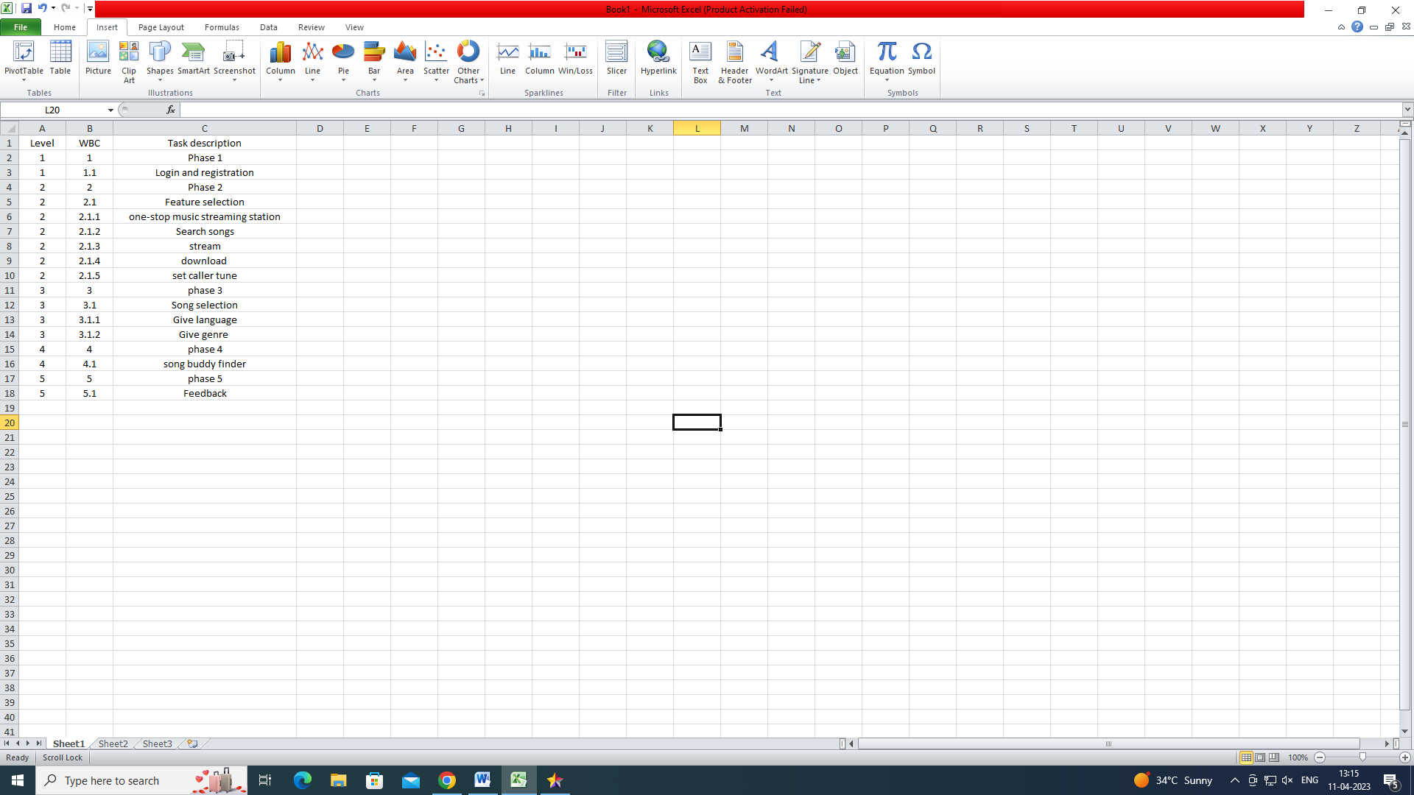

2. Draw the Class diagram for the project

